Module: CASA0029 - Urban Data Visualisation
Student Name: Jianshu Wu
Student Number: 24129347

Spatio-Temporal Analysis of UK Night Lights (2015-2021)
1. Introduction and Aim
This individual visualization project aims to explore the spatio-temporal changes in anthropogenic night-time light (NTL) intensity across the United Kingdom between 2015 and 2021. Night-time light data is widely recognized in urban spatial science as a significant proxy for economic activity, population density, and urbanization levels. By comparing data from 2015 and 2021, this visualization seeks to highlight regional disparities in development and identify major urban agglomerations. The primary goal is to present high-dimensional spatial data in an interactive, accessible 3D web format that allows users to intuitively understand the scale and distribution of light intensity across the country.
2. Data Sources and Processing
The core dataset used is the VIIRS Nighttime Lights (VNL) V2 Annual Composite, provided by the Earth Observation Group (EOG) and NOAA.
- Raw Data: Raster images from the VIIRS Day/Night Band (DNB) sensor were downloaded for the years 2015 and 2021 (WGS 84, EPSG:4326).
- Spatial Analysis: Using QGIS, the raw raster data was clipped to the United Kingdom's administrative boundaries obtained from the ONS Open Geography Portal. To ensure a consistent spatial unit for analysis, a 5km x 5km UK National Grid (EPSG:27700) was initially used to calculate zonal statistics, determining the mean NTL intensity for each grid cell.
- Export: For web compatibility, the processed vector grid data was re-projected and exported as GeoJSON in WGS 84 (EPSG:4326). These files were then uploaded to Mapbox Studio as Tilesets for rendering.

3. Design and Technical Implementation
The visualization is implemented as a single-page web application using Mapbox GL JS v3.9.0.
- Visual Design: A "Black-Gold Fire" color scheme was applied using Mapbox Studio. Low-intensity areas (0-10) are rendered in deep red/black to fade into the background, while high-intensity areas (=89) appear in bright gold. This contrast, set against a purely black "Classic" background (removing satellite imagery and atmosphere), ensures maximum legibility of the data points.
- 3D Visualization: Data is rendered using fill-extrusion, where the height of the grid bars corresponds to light intensity, providing a clear visual representation of urban density.
- Interactivity: A custom HTML/CSS control panel overlays the map. Users can toggle between the 2015 and 2021 datasets to observe changes. Additionally, a "FlyTo" function allows smooth navigation to key urban centers (London, Birmingham, Manchester, Edinburgh, etc.), enhancing user engagement and exploration.
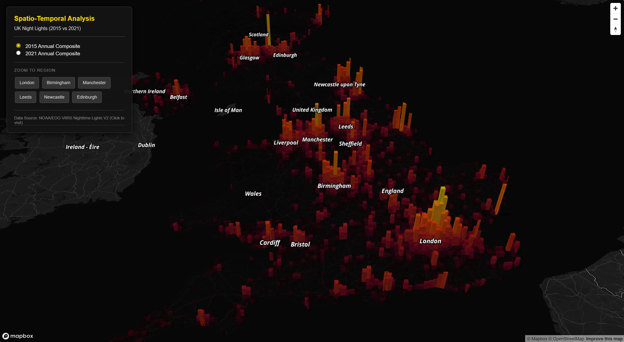
Overview of UK Night Lights showing the 3D extrusion of intensity in London and surrounding areas in 2015
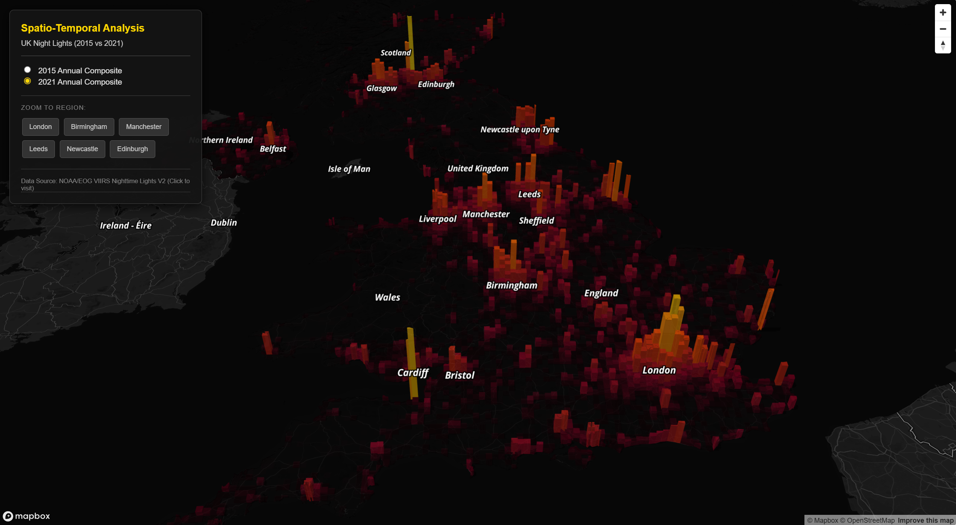
Overview of UK Night Lights showing the 3D extrusion of intensity in London and surrounding areas in 2021

4. Findings and Conclusion
This project successfully demonstrates the use of Mapbox GL JS for visualizing high-resolution spatial datasets. The resulting 3D map provides an intuitive interface for analyzing the urbanization patterns of the UK. Visual comparison reveals that while the overall light intensity across most of the UK remains largely consistent between 2015 and 2021, specific regions exhibit noticeable changes. Notably, the Cardiff area shows a distinct increase in brightness, suggesting localized urban development or increased economic activity in that region. Conversely, the stability in other major cities indicates a mature urban lighting infrastructure. The visualization effectively communicates these nuances through engaging visual design.

References
- Earth Observation Group, Payne Institute for Public Policy. (2022). VIIRS Nighttime Light (VNL) V2. Colorado School of Mines. Available at: https://eogdata.mines.edu/products/vnl/
- Office for National Statistics. (2021). Local Authority Districts (May 2021) Boundaries UK BGC. ONS Geography Open Data at： https://geoportal.statistics.gov.uk/datasets/ons::local-authority-districts-may-2021-boundaries-uk-bgc/about
- Mapbox. (2024). Mapbox GL JS Documentation. Available at: https://docs.mapbox.com/mapbox-gl-js/

